***Senior Project***

Management System

**Team:**

QIYE LI 542115507

YUKE CHEN 542115511

**Advisor:**

Chartchai Doungsa-ard

Department of Software Engineering

College of Arts, Media and Technology

Chiang Mai University



#### Project Proposal

*Table of Contents*

*1. INTRODUCTIONS AND BACKGROUND* 4

    • *Goal of project* 5

*2. LITERATURE REVIEW* 6

    • *Business Review* 6

Similar Application Review 9

Group SMS 9

Google Calendar 9

Tecent QQ 10

    • *Technology Review* 11

Spring 11

JSON 91

Html 5 92

JavaScript 92

*3. QUALITY STANDAR* 13

ISO29110 for Very Small Entity (VSE) 13

Project Management Process 13

Software Implementation Process 13

*4. PROJECT PLAN* 14

   • *Deliverables* 14

*Components of Project* 15

   • *Features List*  17

*Architecture of System* 15

   • *Limits* 19

   • *Schedule and Milestone* 19

*Milestone List* 15

*5. REFERENCE* 21

# *1. INTRODUCTIONS AND BACKGROUND*

**I**n CAMT (C*ollege of Arts, Media and Technology*), there is a significant event for every student in SE program. That is senior project. Senior project is one mandatory project for senior students to complete before graduation. For undergraduates, senior project is the most important project in their college life. Senior project stands for what they have learned during the college study. Besides, they cannot graduate unless they success in senior project.

**D**uring senior project, students have to demonstrate their product to advisers in each senior project development phase. Advisers will grade these works, which will determine the success of the works in the processes. Only works pass the evaluations could get into next process. Then only works pass all evaluations are graded as ’s’. The rule is that no works can fail over two times in one process or fail over three times in total.

**I**n senior project, there are three types of participants: Course coordinator, Advisor, and Student. **Course coordinator** manages all information release to all students and advisors. Course coordinator also manages the presentation time and location follows the rule that for one team there will be three lectures evaluate the works include the team’s adviser. In addition, coordinator needs to manage the statuses of all the teams (‘F’ or ’S’) with the rule that no team can fail over two times in each progress or over three times in total. Another thing coordinator has to take care is the documents, he needs to collect all the assessment scores and analyst them to get the results of evaluations. **Adviser** needs to take few teams as advisees, and keep disgusting with the teams to give them help and suggestions. On the other hand, adviser has to evaluate student’s works for every progress and give commends. **Students** have to group into teams and find one adviser in case of starting senior project. Then students have to finish all the tasks in every progress and attend the presentation of every progress on time. In case of doing a success in senior project, they need to contact with their adviser frequently to get help.

## *Goal of project*

***Purpose:***

**S**enior project management system is a web application that aims at solving the problems in senior project. This system aims at helping the people involve with senior project that are Course coordinator, advisers and students to do their works easily and efficiently.

***Advantage:***

With senior project management system which provides both **website application**:

1. Course coordinator will be able to manage all the information release easier.
2. Course coordinator does not have to manage the presentation schedule and location by doing every thing himself.
3. Course coordinator does not have to get the evaluation results by collecting and analyzing everything himself.
4. Advisers will be able to manage the appointments with their teams easier and more efficiently.
5. Advisers will be able to modify the schedules of works easier.
6. Students will be able to know the changes faster.
7. Students will be able to manage their own works and meetings easier and more efficiently.

# 

# 

# *2. LITERATURE REVIEW*

* *Business Review*

**I**n principle, students have to complete senior project during forth years in group of two people or alone. At first, students who have the qualification and the wish to do senior project will **register** for doing this project. Then students have to group themselves into one group of one or two people. After the first meeting for elucidating the basic principles of senior project, every group has to find one adviser who will give them suggestions during whole processes of senior project. After being taken by one adviser, students would be able to start the first step—proposal.

**D**uring the **proposal phase,** students will prepare the document of proposal as well as the proposal presentation which will be evaluated by three lecturers include the group’s adviser. Only the group pass the proposal presentation could continue to do next step which is design part. The groups who can not pass this at first time will get second chance which can not fail otherwise they have to redo the senior project next year. In additional, students cannot fail three times (get more than 3 times ‘F’) in total.

**A**fter proposal, there are two phases: **project progress I** and **progress II**. In those phases, students have to go through following parts, which are: requirements analysis, software design, software construction, and software testing. The rules of the two phases are exactly same as the rules in proposal part.

**T**hen the projects will come to evaluation process where adviser will evaluate whether it can be demonstrated in Show Pro event or not. If the project pass evaluation from advisors, it can go to Show Pro phase or they can wait until final presentation phase, which will increase one fail time.

**Show Pro** is an event where students publish their projects to all kinds of people like other students, some IT companies etc.

**A**fter the show Pro, the **final presentation** will decide the project is successful or not. Final presentation follows the rules as other phases. Lastly, is checking the English score by the **English Comprehensive Exam**. Students can take the exam anytime during senior project process. If pass, they will get grade of successful of senior project.

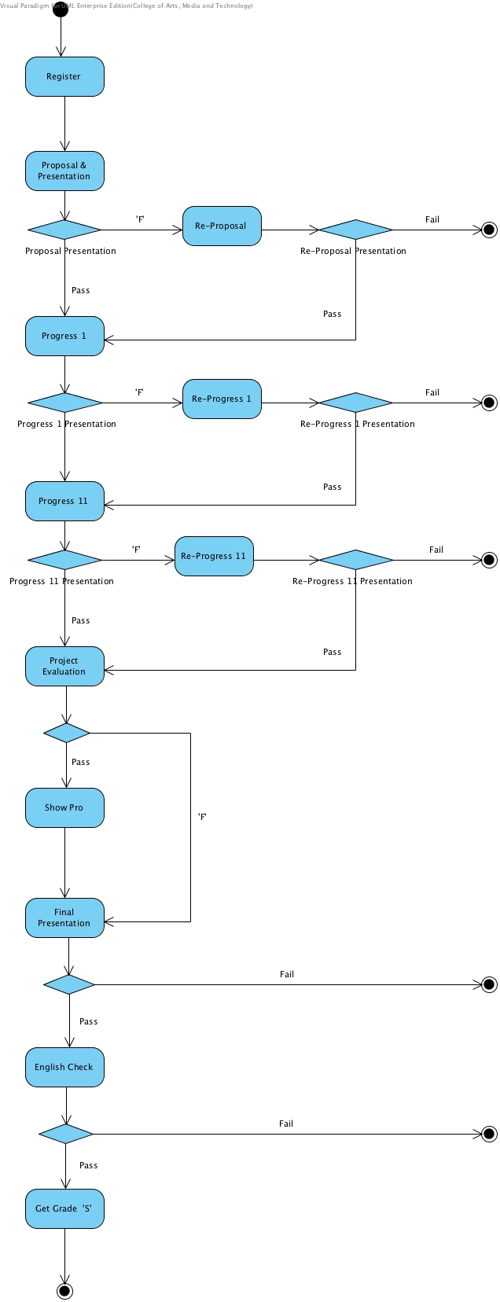

**Figure-1** The activity diagram of senior project

**T**here are 11 major activities in total in senior project that shows in figure 1, some business events occur many times in different activities. Some phases also have many same activities. By cataloging those common parts, the processes of senior project can be summarized to there phase that are Preparing phase represent the register, developing phase and Grading phase.

* **Preparing phase**

1. Students only have paper documents refer to previous senior projects. Each document of previous senior projects has only one piece. Hunger, un-order document is hard to borrow and search information. It spends much time to find what students really want.
2. Students do not know each advisor’s status of accepted teams, it result that student cant be accepted by advisor they expect.
3. Students do not know how many teams are applying for same adviser as them.
4. It is very hard for students to meet adviser because advisers have other works to do.
5. Course coordinator needs group-sending many messages, but the operation is complexity.
6. Course coordinator cannot know whether the email list covers everyone who supposed to get it or not.
7. Course coordinator statistics each advisor and their team by himself. It spends much time and it results in mistakes easily.

* **Developing phase**

1. It is hard for advisors to manage all own teams.
2. It is not easy to manage all versions of teams work.
3. There is no single way to unified manage all own teams.
4. Advisors need team statuses or task process warnings.
5. Students do not have a good time management, and cannot check new schedule on time when the senior project has changes.

* **Grading phase**

1. Course coordinator assigns venue of advisors and teams for each presentation, which is very complexity.
2. Course coordinator receives and calculates each team score from each advisor and records team status by hand.
3. Advisors need grade teams’ works and submit the results to course coordinator.

### 

### *Similar Application Review*

### Group SMS

* **Software description:**

Group SMS [1] is an application that allows a user to send message in-group of people. In additional, it also allows the user has different groups in case of different contacts.

* **Pros**

Group SMSallows the user to send message in-group not individual.

Group SMS allows the user to have more than one group.

Group SMS allows the user to name the groups as their intention.

Group SMS allows the user to create group by adding contacts form the contacts in the devices.

* **Cons**

Group SMSdoes notallow the user to view the status of whether the contacts get the message or not.

Group SMSdoes notallow the user to send files or any others documents except messages.

### Google Calendar

### 

* **Software description**

Google calendar [2] is software that provides the electric calendar for a user to check the time and record important issues in their Daily lives. User can record the issues by the date and time and check the issues with Calendar.

* **Pros**

Google Calendar allows the user to set up the issues by date and time.

Google Calendar allows the user to make an appointment by sending email.

Google Calendar provides the warning to the user.

* **Cons**

Google Calendar does not allow the user to sett the issues with priority level.

Google Calendar does not provide absolutely strong warning to get user’s attention.

### Tecent QQ

* **Software description**

Tencent QQ [3], popularly known as QQ, is an instant messaging software service developed by Tencent Holdings Limited. QQ also offers a variety of services, including online social games, music, shopping, micro blogging, and group and voice chat.

* **Pros**

Tecent QQ allows the user to chat with individual person as well as groups.

Tecent QQ allows the user to group the contacts into different categories.

Tecent QQ allows the user to store the previous messages as he wants.

Tecent QQ allows the user to set their status (visible, invisible, busy).

* **Cons**

Tecent QQ does not allow the user to know whether others read the send message or not.

## *Technology Review*

**Spring**

**S**pring MVC [4] Framework is an open source application framework based on Java for building Java web applications. Spring MVC Framework developed by Spring Source Company. Spring provides the support for Hibernate, JSP, struts, JQuery, and many other frameworks. Spring helps the developer to create high performing, easily testable and reusable code.

*Advantage of Spring MVC framework****:***

We use Spring MVC framework to develop the web application because:

1. Spring MVC has a clearly role definition, for example controller, validator and view resolver.
2. Spring MVC provides the customized handler mapping and view resolution.
3. Spring MVC uses the key-value pair of map to integrate different views.
4. Spring MVC provides the strong JSP tag lib to support many functions like data binding.

**JSON**

**J**SON (JavaScript Object Notation) [5] is a lightweight data-interchange format. It is easy for humans to read and write. It is easy for machines to parse and generate. It is based on a subset of the JavaScript Programming Language, Standard ECMA-262 3rd Edition - December 1999. JSON is a text format that is completely language independent but uses conventions that are familiar to programmers of the C-family of languages, including C, C++, C#, Java, JavaScript, Perl, Python, and many others. These properties make JSON an ideal data-interchange language.

*Advantage of JSON:*

We use JSON to transfer data in senior project management system, because:

1. JSON is compact and can be easily loaded in JavaScript.

2. JSON is smaller than corresponding XML.

3. JSON is fast.

**HTML 5**

**H**TML5 [6] is a markup language used for structuring and presenting content for the World Wide Web and a core technology of the Internet. It is the fifth revision of the HTML standard (created in 1990 and standardized as HTML 4 as of 1997) and, as of December 2012, is a candidate recommendation of the World Wide Web Consortium (W3C) Its core aims have been to improve the language with support for the latest multimedia while keeping it easily readable by humans and consistently understood by computers and devices (web browsers, parsers, etc.). HTML5 is intended to subsume not only HTML 4, but also XHTML 1 and DOM Level 2 HTML.

*Advantage of HTML 5:*

We use HTML5 for structuring and presenting content for the Internet because:

1. With the help of HTML5 it will be very easy to integrate multimedia and graphical content to web without using flash and third party plugins.

**JavaScript**

**J**avaScript (JS) [7] is a dynamic computer programming language. It is most commonly used as part of web browsers, whose implementations allow client-side scripts to interact with the user, control the browser, communicate asynchronously, and alter the document content that is displayed. It has also become common in server-side programming, game development and the creation of desktop and mobile applications.

*Advantage of JavaScript:*

We use JavaScript to add behavior to the web pages where the web page is capable of responding to actions by the visitors because:

1. JavaScript is executed on the client side.

2. JavaScript is a relatively easy language.

3. JavaScript is relatively fast to the end user.

# *3. QUALITY STANDAR*

## **ISO29110 for Very Small Entity (VSE)**

**I**SO29110 [8] is a guide applies to a Very Small Entity (VSE), enterprise, organization, department or project up to 25 people, dedicated to software development. The Guide provides Project Management and Software Implementation processes which integrate practices based on the selection of ISO/IEC 12207- Systems and Software Engineering —Software Life Cycle Processes and ISO/IEC 15289 Software Engineering – Software Life Cycle Process – guidelines for the content of software life cycle process information products (documentation) standards elements.

## **Project Management Process**

**T**he purpose of the Project Management process is to establish and carry out in a systematic way the tasks of the software implementation project, which allows complying with the project’s objectives in the expected quality, time and cost.

**Selected processes:**

* Project Planning Process
* Project Plan Execution Process
* Project Assessment and Control Process
* Project Closer Process

## **Software Implementation Process**

**T**he purpose of the Software Implementation process is the systematic performance of the analysis, design, construction, integration and tests activities for new or modified software products according to the specified requirements.

## **Selected Process:**

* Software Implementation Initiation Process
* Software Requirements Analysis Process
* Software Architectural Design Process
* Software Construction Process
* Software Integration and Test Process

# *4.* *PROJECT PLAN*

## *Deliverables*

* **Developed application**

Full functions as defined in proposal

Deployment package

Initial Data

* **Documents**

Proposal

Project plan

Software requirement specification

Software design document

Testing document

Traceability record

* **Video Clips**

30 seconds Promotion

5 minutes Demo

* **Deployment on the provided server**

## *Components of Project*

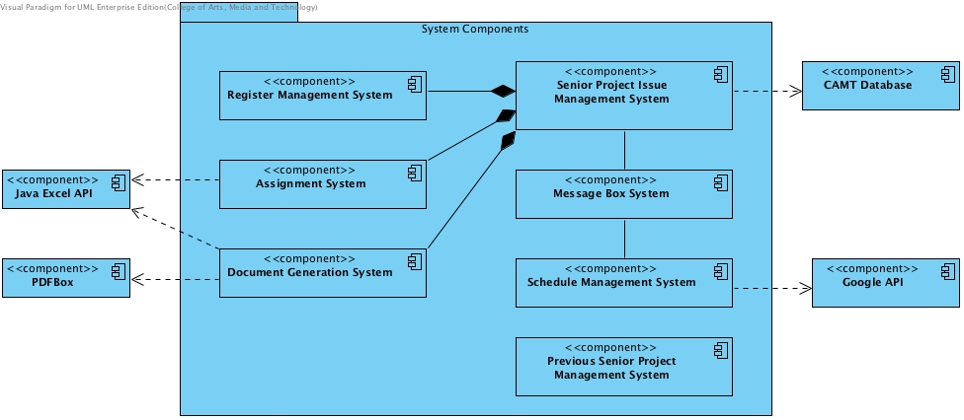

## **Figure-3** Components of Project

**S**enior project management system contains four major components and four dependencies, as figure-3 shows above, the components list:

1. Senior Project Issue Management System

1.1. Register Management System

* 1. Assignment System
  2. Document Generation System

1. Message Box System
2. Schedule Management System
3. Previous Senior Project Management System

**1.Senior Project Issue Management System**

The sub-system deals with the basic issues in two parts of senior project processes, which are preparing phase and grading phase. The issues include students apply advisors, course coordinator publishes presentation venue organization, course coordinator gets the team status from presentation scores etc.

*Dependencies:*

**CAMT Database**

CAMT Database shall provide the information of students and lecturers.

*Inclusive Components:*

**1.1.Register Management System**

The component deals with the tasks in preparing phase since students register the senior project until students are accepted by one of advisors. The tasks are: provide the advisors’ statuses of accepting teams in real time and statistic advisors and their teams.

**1.2.Presentation Grading System**

The component deals with a several of petty tasks occur along with the presentations. The tasks include three types that are organizing task, grading task, and statistic task. Organizing task generates the appropriate participants include advisers and students, locations and time for presentations follow the rule that for every team there will be three lectures evaluate the works include the team’s adviser. Grading task allows advisers to login to system via their PCs to give the grades and send the results to course coordinator. Statistic task receives and calculates each team score from each advisor and records team status automatically.

*Dependencies:*

**Java Excel API**

System uses Java Excel API [9] to read data from presentation grade excel files and write the calculate results.

**1.3.Document Generation System**

The system deals with all relevant documents, which are importing data to module document to generate documents and exporting documents for reading and loading. The documents have Excel and PDF two kinds of standards.

*Dependencies:*

**Java Excel API**

The API provides methods for processing Excel files.

**PDFBox**

The API [10] provides methods for processing PDF files.

**2.Message Box System**

The sub-system deals with message notifications issues. Messages include two types that are short messages and requests. Short messages are the contents send by others that can be read while requests are established messages with specific intentions that can be accepted or refused. With the two kinds of messages, the subsystem can manage the cases that users have short communications with others by messages and advisors take teams’ requests.

**3.Schedule Management System**

The sub-system deals with the all the issues related to schedule throughout whole process of senior project. The issues include record new changes to related schedules automatically, add appointments to related schedules automatically, and remind the emergency events.

*Dependencies:*

**Google API**

Google API [11] provides Calendar and Gmail components used to manage the schedule.

**4.Previous Senior Project Management System**

The sub-system deals with all tasks related to previous senior projects, which means that system provides sorted previous senior projects and various search methods for searching the projects.

## *Features List*

* + - 1. *Architecture of System*

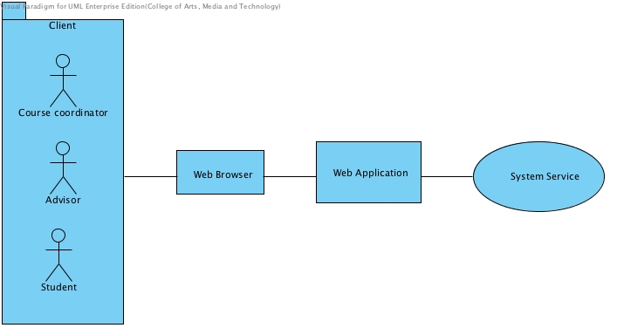

**Figure-4:** Architecture of System

Target User:

Course Coordinator

Adviser

Student

Web application:

* Course Coordinator

1. Manage the senior project schedule for whole process, share schedule event to each participator’s schedule.
2. Inform messages by group to register students, advisers etc.
3. Generate presentation detail for venue, time and people that satisfy the senior project presentation rules.
4. Import and export project relevant documents whose data are read or written by system such as:

*‘Proposal presentation Registration Form’*

*‘The proposal presentation venues’*

*‘Proposal Presentation Assessment Form’*

1. View presentation grade results and each team status for ‘F’ times that are produced by system.

* Adviser

1. Edit profile information such as identify picture, interested technologies, project topics etc.
2. Manage appointments such as send appointment requests to students, edit appointment time, locations etc.
3. Take teams by accepting students take advisor requests.
4. Manage the schedule for own teams. Add or edit schedule events, share the events to students.
5. View own teams statuses.

* Student

1. Register senior project course.
2. View real-time statuses of the advisors of taking teams in register phase.
3. Search, view advisors, makes appointments with the advisor they chose.
4. View own team schedule and manage own schedule events.
5. Inform team status with ‘F’ times.
6. Scan previous senior project resource to find a topic or idea.

## *Limits*

* Senior Project Management System shall not provide the version control for managing senior projects.
* Senior Project Management System shall not be used on mobile operating system.
* Senior Project Management System shall only use to the senior project management for CAMT software engineering major.

## *Schedule and Milestone*

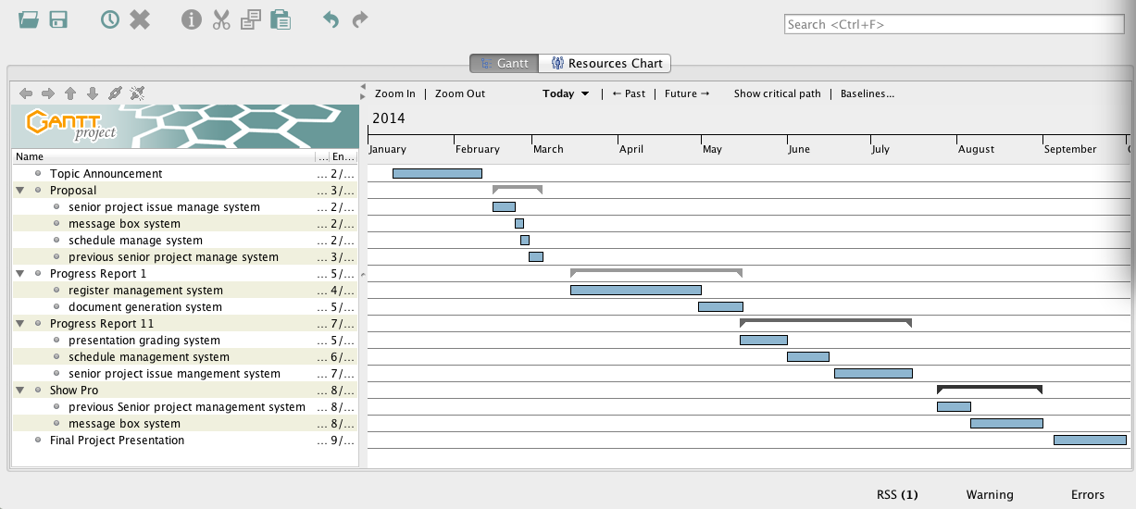

**Figure-4:** Schedule Plan

Senior Project Management System contains six milestones as what show in figure-4. The whole process costs **238** days in total form January to September. Each item are described as figure-5 show in follows:

|  |  |  |  |  |
| --- | --- | --- | --- | --- |
| No. | Phase Name | Time | Content | Inclusive Features |
| 1 | Topic Announcement | 32 days |  |  |
| 2 | Proposal | 18 days | Proposal | All |
| 3 | Progress Report Ⅰ | 62 days | 1.1 Register Management System  1.3 Document Generation System | 8 11 12 13 4 5 |
| 4 | Progress Report Ⅱ | 62 days | 1.2 Assignment System  3. Schedule Management System  1. Senior Project Issue Management System | 5  1 7 9 13 14  2 3 6 10 13 15 |
| 5 | Show Pro | 38 days | 4. Previous Senior project Management System  2. Message Box System | 16  2 8 7 9 13 |
| 6 | Final Project Presentation | 26 days | All functions of product | All |

**Figure-5:** Milestone List

# *5. REFERENCE*

[1] **Group SMS:** <http://www.grouptext.info/Group_Text/Group_SMS.html>

[2] **Google Calendar:** <http://www.google.com/intx/en_th/enterprise/apps/business/products.html#calendar>

[3] **Tencent QQ:** <http://en.wikipedia.org/wiki/Tencent_QQ>

[4] **Spring:** <http://projects.spring.io/spring-framework/>

[5] **JSON:** <http://json.org/>

[6] **Html 5:** <http://en.wikipedia.org/wiki/HTML5>

[7] **JavaScript:** <http://en.wikipedia.org/wiki/JavaScript>

[8] **Quality standard:** <http://en.wikipedia.org/wiki/ISO_29110>

[9] **JExcel API:** <http://jexcelapi.sourceforge.net/>

[10]  **PDFBox:** <http://pdfbox.apache.org/>

[11] **Google APIs:** https://developers.google.com/